August 2024
Blackboard Deeplinking Instructions – LTI1.3

*Please Note: The following instructions are for deeplinking Gale content into your courses learning path. If you do not see any Gale Databases; Please direct Blackboard Administrator to Blackboard LTI 1.3 Admin Installation Guide

Navigate to the desired course you are wanting to deeplink Gale content into.
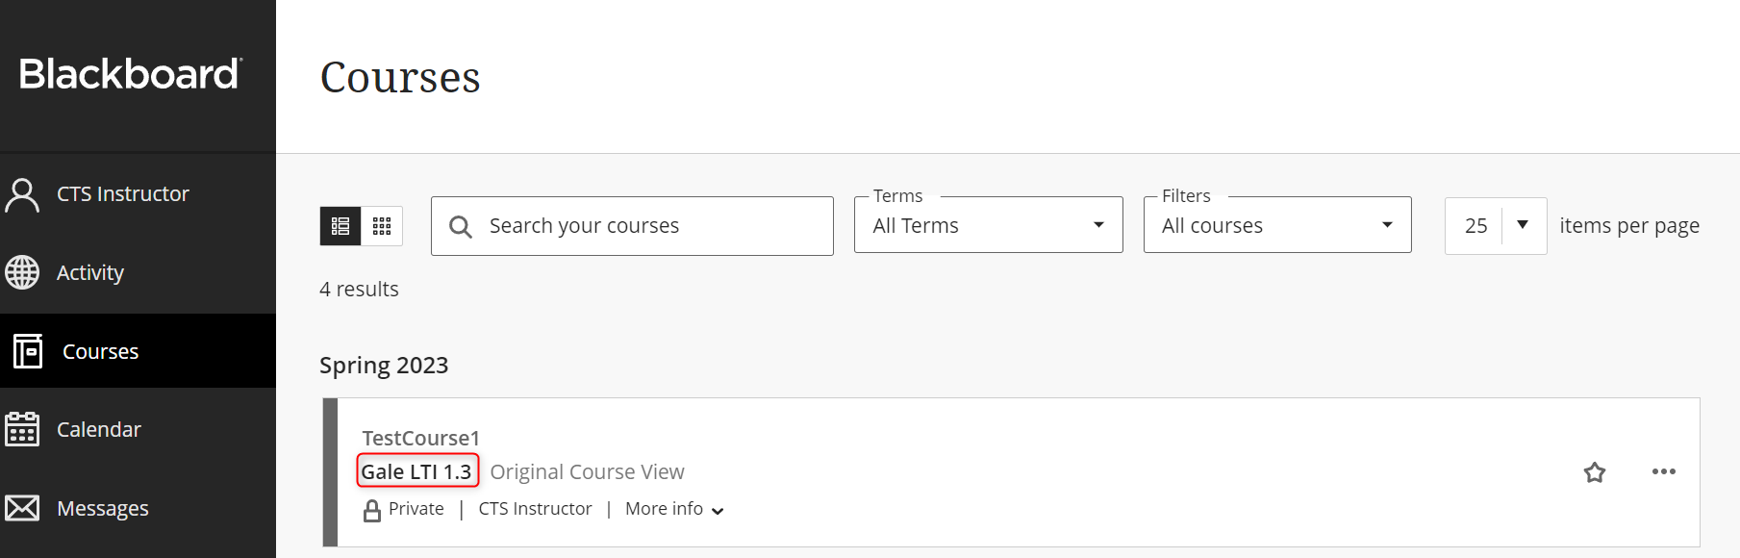

Select Content
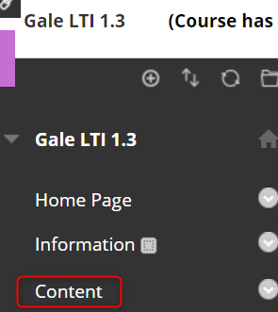

Select Build Content then your Gale database from the dropdown menu.

From the tool, perform a search and select the proper result.
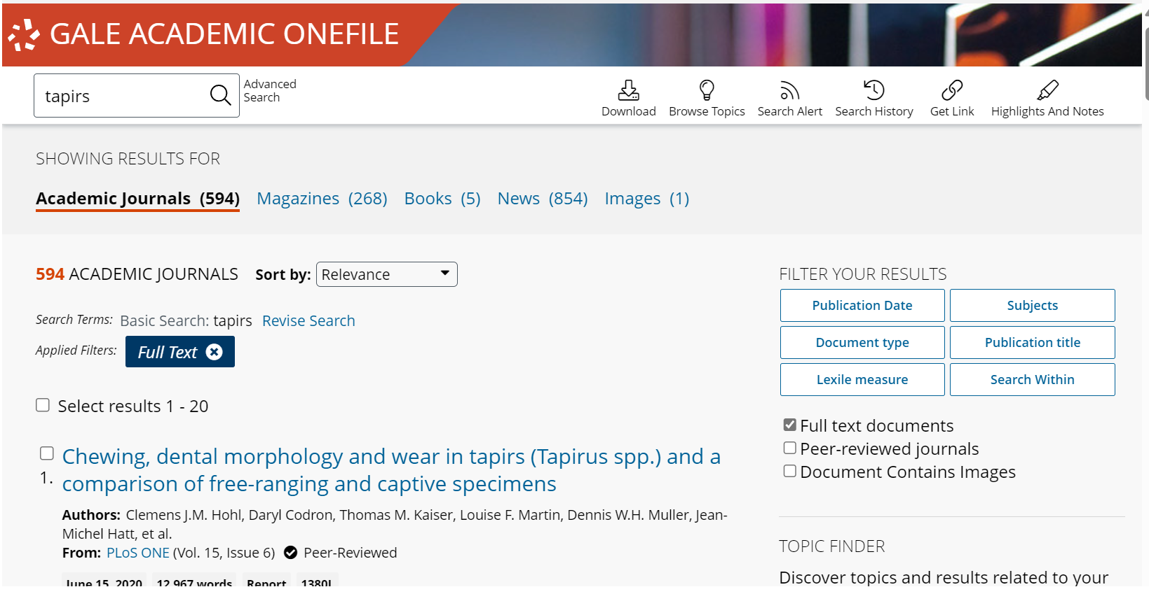

On the article page, choose to link or embed the article as needed.
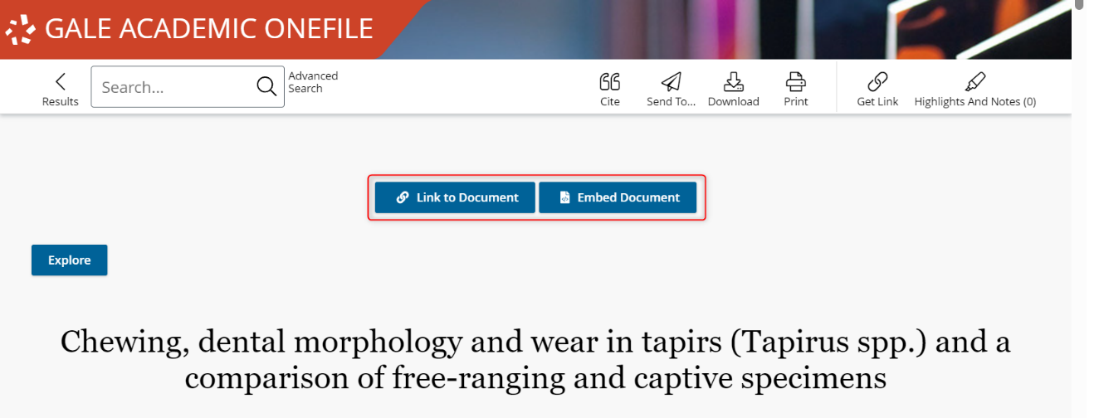
The article will now appear as content in the course selected.
